What do you mean by Spring Singleton scope?"

Most of the time, I get an answer like, "Spring Singleton scope manages only one object in the container."
After getting this answer, I ask the next question, "Please tell me what the output of the following program would be."

<?xml version="1.0" encoding="UTF-8"?>
<beans xmlns="http://www.springframework.org/schema/beans"

xmlns:xsi="http://www.w3.org/2001/XMLSchema-instance"

xsi:schemaLocation="http://www.springframework.org/schema/beans

http://www.springframework.org/schema/beans/spring-beans-3.0.xsd">

<bean id="scopeTest" class="com.example.scope.Scope" scope="singleton">

<property name="name" value="Shamik Mitra"/>

</bean>

<bean id="scopeTestDuplicate" class="com.example.scope.Scope" scope="singleton">

<property name="name" value="Samir Mitra"/>

</bean>

</beans>

package com.example.scope;
public class Scope {

private String name;

public String getName() {

return name;

}

public void setName(String name) {

this.name = name;

}

@Override

public String toString() {

return "Scope [name=" + name + "]";

}

}

package com.example.scope;
import org.springframework.context.ApplicationContext;

import org.springframework.context.support.ClassPathXmlApplicationContext;

public class Main {

public static void main(String[] args) {

ApplicationContext ctx = new ClassPathXmlApplicationContext(

"configFiles/Scope.xml");

Scope scope = (Scope) ctx.getBean("scopeTest");

Scope scopeDuplicate = (Scope) ctx.getBean("scopeTestDuplicate");

System.out.println(scope == scopeDuplicate);

System.out.println(scope + "::" + scopeDuplicate);

}

}

Here, I create two beans of the Scope class and make Spring Scope a singleton, now checking the references.
This is where interviewees sometimes get confused. Usually, I will get three types of answers:

- This code will not compile. It will throw an error at runtime, as you can not define two Sspring beans of the same class with Singleton Scope in XML. (Very rare)
- The reference check will return true, as the container maintains one object. Both bean definitions will return the same object, so the memory location would be the same. (Often)
- The reference check will return false, which means Spring Singletons don't work like they said earlier. (A few)

The third answer is the correct answer. A Spring Singleton does not work like a Java Singleton.

Spring Singleton vs Singleton Pattern

Singleton scope is the default scope in Spring. Spring container create exactly one instance of the object defined by that bean definition.

Singleton scope in Spring is not same as singleton pattern. Some of the main differences between these 2 are

- Singleton pattern ensures one instance of a particular class of per class loader.
- Spring Singleton is “per container per bean”.
If you pay close attention, these are entirely different design in terms of how they define singleton.

1.1 Singleton Scope Example

Singleton instance in Spring will be stored in a cache of such singleton beans, and all subsequent requests and references for that named bean will result in the cached object being returned.

Let’s work on an example to understand it more clearly.
public class CustomerAccount {

private String name;

public CustomerAccount() {
}

public CustomerAccount(String name) {
this.name = name;
}

@Override
public String toString() {
return "CustomerAccount{" +
"name='" + name + '\'' +
'}';
}
}

Spring Boot main method
@SpringBootApplication
public class DemoApplication {

public static void main(String[] args) {

SpringApplication.run(DemoApplication.class, args);
}

@Bean(name = "bean1")
public CustomerAccount customerAccount(){
return new CustomerAccount("Test User 1");
}

@Bean(name = "bean2")
public CustomerAccount customerAccount1(){
return new CustomerAccount("Test User 2");
}
}

Let’s understand this code.
We created 2 instances of the same class with different bean id.

How many instances created by Spring IoC container for above example?

- separate instances in the container bind to their Id’s?
- instance bind to 2 bean ids?

1.2 Test Case

To get an answer to the above questions, let’s create a unit test case for our example.
@RunWith(SpringRunner.class)
@SpringBootTest
public class SingletonScopeTest {

private static Logger log = LoggerFactory.getLogger(SingletonScopeTest.class);

@Resource(name = "bean1")
CustomerAccount account1;

@Resource(name = "bean1")
CustomerAccount duplicateAccount;

@Resource(name = "bean2")
CustomerAccount account2;

@Test
public void testSingletonScope(){
log.info(account1.getName());
log.info(account2.getName());

log.info("account are equal:: {}", account1 == account2);
log.info("Duplicate Account :: {}", account1 == duplicateAccount);
}
}

Output
2018-01-15 21:53:29.171 INFO 8421 --- [ main] com.example.demo.SingletonScopeTest : Test User 1
2018-01-15 21:53:29.171 INFO 8421 --- [ main] com.example.demo.SingletonScopeTest : Test User 2
2018-01-15 21:53:29.171 INFO 8421 --- [ main] com.example.demo.SingletonScopeTest : account are equal:: false
2018-01-15 21:53:29.172 INFO 8421 --- [ main] com.example.demo.SingletonScopeTest : Duplicate Account :: true

we can understand that Spring returns two different instances.
- More than one object of the same class for the singleton scope.

For a given Id, Spring container maintain only one shared an instance of singleton bean. In our example
- Spring Ioc container created 2 instances of the same class based on bean definition and binds them with ids.
- Spring bean definition work as a key-value pair, the key is mapped to bean id and value mapped to the bean instance.
- Each key reference returns the same bean instance (refer to “bean1” always return bean instance associated with id “bean1”).

Summary
Spring Singleton is very different from Singleton pattern. Spring guarantees to create only one bean instance for given bean id definition per container.Singleton pattern ensures that one and only one instance is created per ClassLoader.

The third answer is the correct answer. A Spring Singleton does not work like a Java Singleton.

If we see the output of the program, we will understand that it will return two different instances, So in a container, there may be more than one object in spite of the fact that the Scope is the singleton.

Output:
Reference Check ::false

Scope [name=Shamik Mitra]::Scope [name=Samir Mitra]

So, let's ask the question again. "What do you mean by Spring Singleton Scope?"
According to the Spring documentation:
"When a bean is a singleton, only one shared instance of the bean will be managed, and all requests for beans with an id or ids matching that bean definition will result in that one specific bean instance being returned by the Spring container.
To put it another way, when you define a bean definition and it is scoped as a singleton, then the Spring IoC container will create exactly one instance of the object defined by that bean definition. This single instance will be stored in a cache of such singleton beans, and all subsequent requests and references for that named bean will result in the cached object being returned."

So it is clear that for a given id, a Spring container maintains only one shared instance in a singleton cache.

In my example, I use two different ids (scopeTest and ScopeTestDuplicate), so the Spring container creates two instances of the same class and binds them with respective ids, then stores them in a Singleton cache.
You can think of a Spring container as managing a key-value pair, where the key is the id or name of the bean and the value is the bean itself. So, for a given key, it maintains a Singleton. So if we use that key as a reference to or of other beans, the same bean will be injected to those other beans.
In summation, Spring guarantees exactly one shared bean instance for the given id per IoC container, unlike Java Singletons, where the Singleton hardcodes the scope of an object such that one and only one instance of a particular class will ever be created per ClassLoader.
And we'll close on this picture taken from the Spring docs.

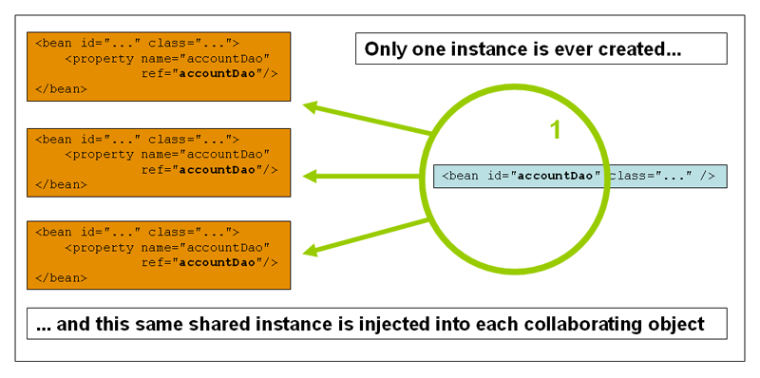

When to use Spring prototype scope?

Prototype scope = A new object is created each time it is injected/looked up. It will use new SomeBean() each time.
- Singleton scope = The same object is returned each time it is injected/looked up. Here it will instantiate one instance of SomeBean and then return it each time.

Prototype bean is created at the time of usage. So when you would like to have statefull beans there is strong need sometimes to have prototypes scope or when you don't wont to cache any values in beans.

Prototype bean can be associated with one session or some call.

Example:
A data access object (DAO) is not typically configured as a prototype, because a typical DAO does not hold any conversational state; it was just easier for this author to reuse the core of the singleton diagram

What is Stateless Object in Java?

Stateless object is an instance of a class without instance fields (instance variables). The class may have fields, but they are compile-time constants (static final).
A very much related term is immutable. Immutable objects may have state, but it does not change when a method is invoked (method invocations do not assign new values to fields). These objects are also thread-safe.

If the object doesn't have any instance fields, it it stateless. Also it can be stateless if it has some fields, but their values are known and don't change.

class Stateless {
void test() {
System.out.println("Test!");
}
}

class Stateless {
//No static modifier because we're talking about the object itself
final String TEST = "Test!";

void test() {
System.out.println(TEST);
}
}

class Immutable {
final String testString;

Immutable(String testString) {
this.testString = testString;
}

void test() {
System.out.println(testString);
}
}

Stateful beans and Stateless beans in Spring context

- I came to a line that uses prototype scope for all stateful beans while
- singleton for stateless beans.

From spring perspective
- stateless beans: beans that are singleton and are initialized only once. The only state they have is a shared state. These beans are created while the ApplicationContext is being initialized. The SAME bean instance will be returned/injected during the lifetime of this ApplicationContext.

- stateful beans: beans that can carry state (instance variables). These are created EVERY time an object is required (like using the "new" operator in java).

Basically, a well written spring bean should be stateless with only dependency injected, thread local, instance variables. With that in mind, there's really no "global state" or shared state to speak of.

Services are singletons ?

Yes that makes sense. Services are normally singletons. I wouldn't see a good reason to need multiple instances within a web application on a single node. If you use Spring for your dependency injection, singleton is already the default scope.

Of course this assumes the services are stateless, i.e. don't hold session or request related data.

Q: All of my services need to handle a single piece of stateful information related to the web user's session. The last line W_EMP is my "webuser" object which holds this information. However, this information is used by the controllers for display purposes only. Is there a good way to handle that kind of stateful information and still convert the Dao services to singletons?
A: You should not keep the webuser as a field in any of your singleton components since web applications are usually multi-threaded. If you did, a user could be presented with the details of another user. It does not matter that the data is read-only, since it is still different data for different threads/users.
S:Beware: Controller are traditionally singletons (and should be stateless) for the same reasons that services should be.

A: This pattern is really standard. Most MVC examples should show this. Content served by a controller should not be stored in fields inside the controller. It can be obtained from the HTTP session (this used to be quite standard, but not common anymore due to scalability issues amongst other things), a local repository (e.g. database) or a call to a remote service

Why Spring controllers are singleton for REST implementations?

Spring beans are, by default, singleton scoped. Since component scanning a @Controller annotated class simply generates a bean, that bean will be singl

For reasons why a @Controller bean should be stateless, read any and all of the following:

- Are Spring MVC Controllers Singletons?
- Controller's life-cycle in Spring MVC

each request contains all the information it needs for the server to handle it. Knowing that, it's pointless for the server (or @Controller) to keep any information after it's finished handling the request in instance fields and the like. Therefore a singleton is the way to go.

Are Spring MVC Controllers Singletons?

Spring controllers are singletons (there is just one instance of each controller per web application) just like servlets.

By default, Spring beans are singletons. Spring suggests to use singletons for stateless beans like controllers and DAOs, and prototype scope for stateful beans.

what is so bad about singleton)

three problems of singleton are:
- Hide dependencies of the application in the code
- Violation of single responsible principle
- Code strong coupled

None of them is present if you use the singleton via spring dependency injection,

because:
- Dependencies are stored in the configuration file, not in the code
- The single responsible principle is not broken because the construction of your dao is handled by the spring engine, not by your dao
- Code is not strong coupled because the configuration can be changed without changing the code
So yes using spring singletons can be a very nice solution not having problems of real singletons.

Why @Service on DAO?

I read online, @Service is for service layer (business logic), @Controller is for the API endpoint, and @Repository is used for persistence layer.
In my company, the code structure is:

Client -> Rest endpoint -> service -> DAO -> database

What confused me is, in the DAO layer, is annotated as @Service (actually both service and DAO layer also annotated as @Service)

Is there any reason that DAO annotated as @Service? i couldn't ask the programmer because he is on leave.

----

With @Component, @Repository, @Service and @Controller annotations in place and after enabling automatic component scanning, spring will automatically import the beans into the container so you don’t have to define them explicitly to autowire them.

@Component
The @Component annotation marks a java class as a bean so the component-scanning mechanism of spring can pick it up and pull it into the application context. To use this annotation, apply it over class as below:

@Repository
Although above use of @Component is good enough but you can use more suitable annotation that provides additional benefits specifically for DAOs i.e. @Repository annotation. The @Repository annotation is a specialization of the @Component annotation with similar use and functionality. In addition to importing the DAOs into the DI container, it also makes the unchecked exceptions (thrown from DAO methods) eligible for translation into Spring DataAccessException

@Service
The @Service annotation is also a specialization of the component annotation. It doesn’t currently provide any additional behavior over the @Component annotation, but it’s a good idea to use @Service over @Component in service-layer classes because it specifies intent better. Additionally, tool support and additional behavior might rely on it in the future.

@Controller
@Controller annotation marks a class as a Spring Web MVC controller. It too is a @Component specialization, so beans marked with it are automatically imported into the DI container. When

you add the @Controller annotation to a class, you can use another annotation i.e. @RequestMapping; to map URLs to instance methods of a class.
In your scenario, it has no impact on application flow whether you use @Service or @Repository, application will work as they are elligible for autowiring. But standard practice is to use @Repository for dao classes.

Where should “@Transactional” be place Service Layer or DAO

Ideally, Service layer (Manager) represents your business logic and hence it should be annotated with @Transactional.
Service layer may call different DAOs to perform DB operations. Lets assume a situation where you have 3 DAO operations in a service method. If your 1st DAO operation failed, other two may be still passed and you will end up with an inconsistent DB state. Annotating Service layer can save you from such situations.

The Service is the best place for putting @Transactional, service layer should hold the detail-level use case behavior for a user interaction that would logically go in a transaction. in this way we can have maintain separation between web application code and business logic.

What's the difference between @Component, @Repository & @Service annotations in Spring?

Annotation │ Meaning │
├────────────┼─────────────────────────────────────────────────────┤
│ @Component │ generic stereotype for any Spring-managed component │
│ @Repository│ stereotype for persistence layer │
│ @Service │ stereotype for service layer │
│ @Controller│ stereotype for presentation layer (spring-mvc)

What’s special about @Component
<context:component-scan>
only scans @Component and does not look for @Controller, @Service and @Repository
in general. They are scanned because they themselves are annotated with @Component.

@Repository
This is to indicate that the class defines a data repository.

What’s special about @Repository?
In addition to pointing out, that this is an Annotation based Configuration, @Repository’s job is to catch platform specific exceptions and re-throw them as one of Spring’s unified unchecked exception. For this, we’re provided with PersistenceExceptionTranslationPostProcessor, that we are required to add in our Spring’s application context like this:

@Controller
The @Controller annotation indicates that a particular class serves the role of a controller. The @Controller annotation acts as a stereotype for the annotated class, indicating its role.

What’s special about @Controller?
- We cannot switch this annotation with any other like @Service or @Repository, even though they look same.

- The dispatcher scans the classes annotated with @Controller and detects methods annotated with @RequestMapping annotations within them. We can use @RequestMapping on/in only those methods whose classes are annotated with @Controller and it will NOT work with @Component, @Service, @Repository etc...

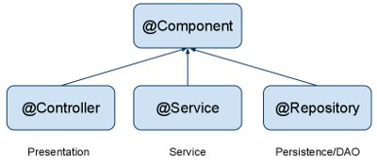

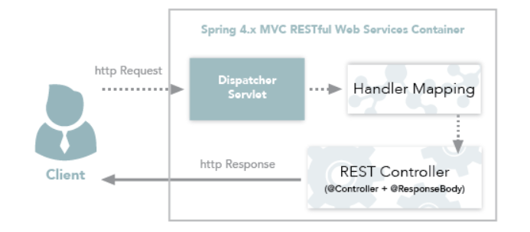

In a spring application, why are Dao, service and repository singleton?

I am new to spring. I have learnt that Dao, service and repository are all singletons. Why is this?
If I am making a web application, multiple users will be trying to access it at the same time. This means the singleton has only a single object and it will be shared with multiple users requests. Will this cause issues as each request will contain different type of information?

A:
Why not. There is nothing preventing using a singleton in multiple threads as long as you don't store state in them. Generally you don't do things like that in a service or dao, all the state is scoped to inside a method not the class itself.

Controller's life-cycle in Spring MVC

Dao , repo , service are sigleton in spring

how spring singleton scope for DAO class works internally

Should a DAO be singleton or not?

